Lori Trahan highlights $9.6M in federal funding for Route 3A improvements in Billerica

By Peter Currier | pcurrier@lowellsun.com | Lowell Sun
September 6, 2023 at 6:34 p.m.

BILLERICA — U.S. Rep. Lori Trahan and town officials announced Wednesday that Billerica will receive more than $9.6 million in federal funding from the 2021 Bipartisan Infrastructure Investment and Jobs Act for the ongoing project to rehabilitate Boston Road.
The sounds of construction permeated in the background from the very project the federal funding is meant to pay for as Town Manager John Curran touted the benefits of rehabilitating Boston Road. The rehabilitation of the busy road is meant to improve safety for drivers and pedestrians, increase traffic efficiency and improve infrastructure for cyclists and pedestrians.
As the construction on Boston Road continues, Town Meeting members in Billerica will be thinking about whether to vote for another project to renovate the nearby town center, which is estimated to cost $20 million. The town center project will be on the warrant for the fall Town Meeting next month.
“What we hope in the future is that we will connect these two projects in the middle,” said Curran.
Trahan said that while infrastructure is rarely the most exciting thing to talk about or highlight, it is immensely important to the function of local communities.
“It is so much more than filling a few pot holes, as you well know. It is about the safety of our community. It is about setting the groundwork for economic development and vibrancy of a community,” said Trahan. “If we can’t rely on the structural integrity of our major roadways, like Route 3A, then we can’t use them for corridors of development.”
Trahan said road infrastructure and maintenance has suffered from divestment from the federal government over the years, and that important projects had been “kicked down the road” for years at a time. She said that was a result of both Democrats and Republicans talking about the need for infrastructure investment but making little actual progress.
“That changed with President Biden, which is a really enormous part of this administration with the last Congress stepping up and passing the Bipartisan Infrastructure Law, which is really helping to transform towns like Billerica that have long been left to fend for themselves,” said Trahan. “The law is delivering $9.5 billion, minimum, to the state of Massachusetts in federal funding over the next few years. I couldn’t be prouder that this funding is finally going to end the cycle of deferred maintenance we have gotten way too used to in terms of our state’s aging infrastructure.”

Next year, Trahan said, Billerica will also receive federal funding to the tune of $7.6 million to construct an extension of the Yankee Doodle Bike Path that would connect Billerica Memorial High School to the Marshall Middle School.
The Boston Road/Route 3A project extends 3,800 feet from Simmons Lane to the north end of the town center. The project is also within the town’s historic district, and the improvements being done reflect that by including ornamental street lights and traffic signals. The project will also feature brick pavers on the sidewalk, an island on the shared use path and the relocations of a utility wire crossing Boston Road from overhead to underground.
- 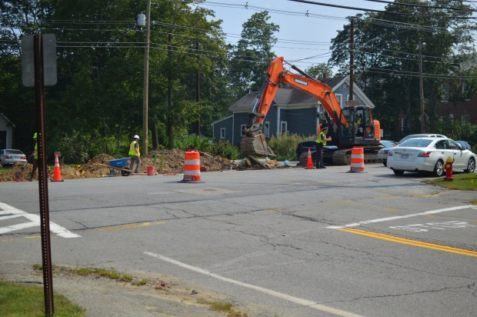
Construction was ongoing in the rehabilitation of Boston Road/Route 3A in Billerica Sept. 6, 2023 as U.S. Rep. Lori Trahan and Billerica officials highlighted $9,652,326 in federal funding for the project. (Peter Currier/Lowell Sun)
- 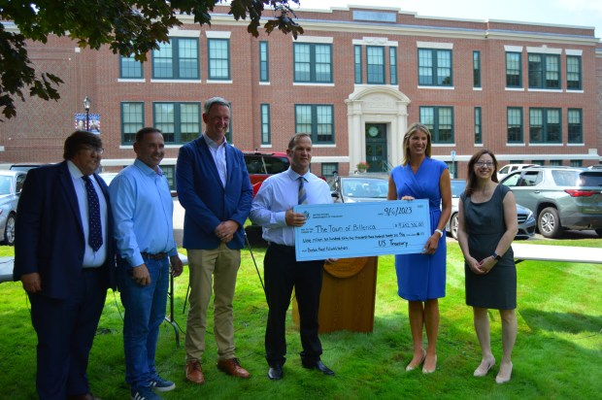
From left, Billerica Town Manager John Curran, Select Board members John Burrows, Andrew Deslaurier and Chair Michael Riley, U.S. Rep. Lori Trahan and Northern Middlesex Council of Governments Executive Director Jennifer Raitt in front of Billerica Town Hall Sept. 6, 2023 to highlight $9,652,326 in funding for the ongoing Boston Road/Route 3A rehabilitation project. (Peter Currier/Lowell Sun)

